PAPER TITLE
First Author¹, SecondAuthor² and Third Author³
¹Affiliation, Centered , Italic, Times New Roman 10
²Affiliation if different from 1, Centered, Italic, Times New Roman 10
³Affiliation if different from 1 and/or 2, Centered, Italic, Times New Roman 10.

ABSTRACT
The total length of the paper should not exceed 8 pages. The abstract should be at least 150 words, but not exceed one page.
The first section of the paper should be a single-paragraph abstract outlining the aims, scope and conclusions of the paper.

KEYWORDS
A keyword section should follow immediately the abstract section. List about 4-5 keywords separated by commas and ending with a stop.

Introduction
The author should give a brief background of the work and the studies explored previously by other researchers. Submitted papers should contain detail and reference to public sources of information so that the author’s peers are able to repeat the work or otherwise verify its accuracy. References to published work should be referred to in the text by the last name(s) of author(s) followed by the year of publication in parentheses. For example, one may write “Smith et al. (2013) referred to several existing studies (Ferrier 2000, 2011, 2012a, 2012b; Caron et al. 2002; Benzarti and Ferrier 2003) …” or “More information can be found in Caron et al. (2002).”

RESEARCH SIGNIFICANCE
An author’s central obligation is to present a concise account of his or her research, work or project accompanied by an objective discussion of its significance.

RESEARCH METHODOLOGY
Give a description of the specification of the materials used in the study. If it is an experimental work, then give the detailed process involved in achieving the desired outcomes.

Assumptions
If any assumptions are made the study, please include in the following manner
(1) Assumption 1
(2) Assumption 2 and so on.

Equations
Equations and formulae should be typed in Mathtype, and numbered consecutively with Arabic numerals in parentheses on the right-hand side of the page (if referred to explicitly in the text). They should also be separated from the surrounding text by one space.
(1)

RESULTS AND DISCUSSIONS
The author should explain the outcomes of the works carried out and discuss in detail. The figures and tables should be presented in the following manner.

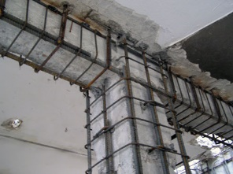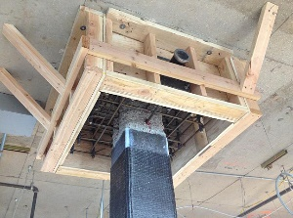
(a) Legend 1a (b) Legend 1b

Figure 1 : Legend

Table 1: Title of table 1
Title | Column 1 | Column 2 | Column 3
And an entry | 1 | 2 | 3
And an entry | 4 | 5 | 6
And an entry | 7 | 8 | 9

CONCLUSIONS
The author should summarize the whole paper and explain its main purpose and the key points of the study.

ACKNOWLEDGMENTS
The author should thank all those who (people, agency, etc.) supported them in this work.

References
E. Ferrier, O. Rabinovitch, L. Michel (2016). “Mechanical behavior of concrete–resin/adhesive–FRP structural assemblies under low and high temperatures”, Construction and Building Materials, 127, 1017-1028.
M. Lahouar, J.F Caron, N. Pinoteau, G. Forêt, K. Benzarti (2017). “Mechanical behavior of adhesive anchors under high temperature exposure: Experimental investigation”, International Journal of adhesion and adhesives, 78, 200-211.

